ExtractEventsForEEGLAB: Importing Event Data into EEGLAB

This application is used to create CSV (Comma Separated Variable) files which can be used to import these Events into EEGLAB environment.

When it is opened, the application displays this window. Click on the “Open RWNL” button to process a new dataset.

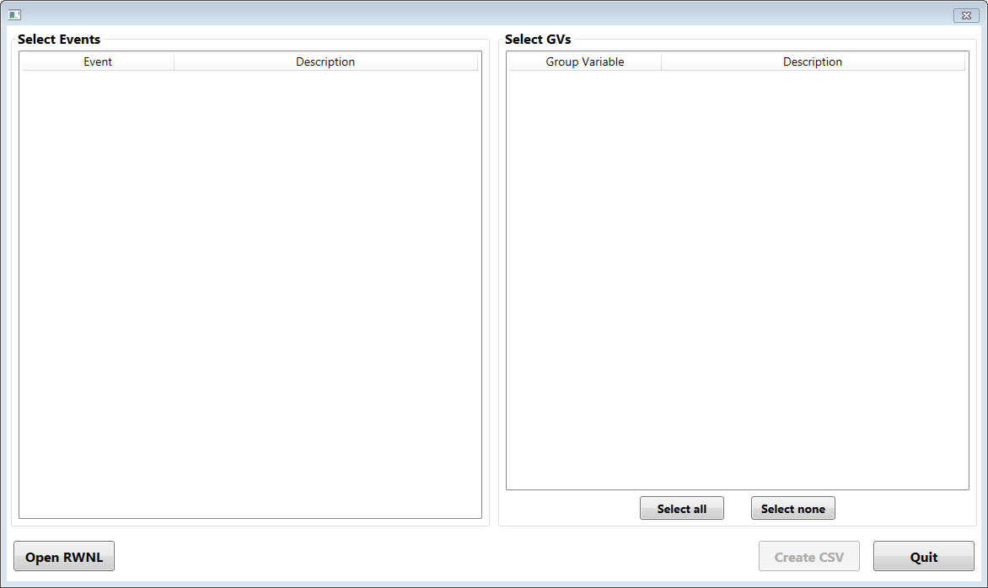

The application opens the corresponding RWNL dataset and displays the Event types that are available in the dataset. Choose one or more of these by click on the entries.

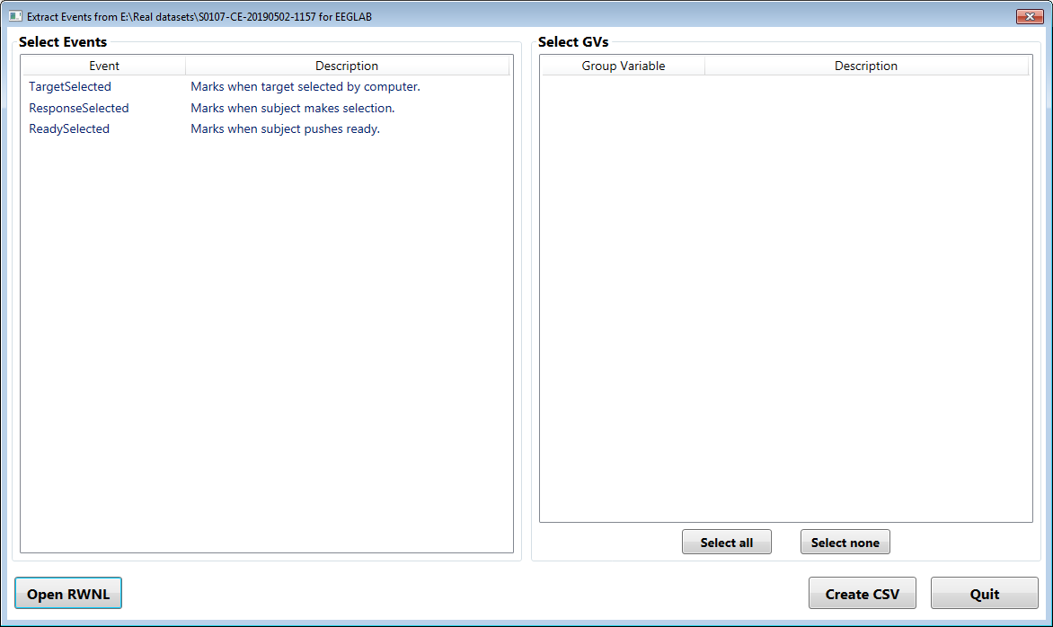

As each Event is selected, the Group Variables (GV) are updated in the box on the right. Each Event has a set of GVs associated with it. If more than one Event is selected, the displayed GVs are the intersection of these sets of GVs. Thus each GV will have a value for every selected Event.

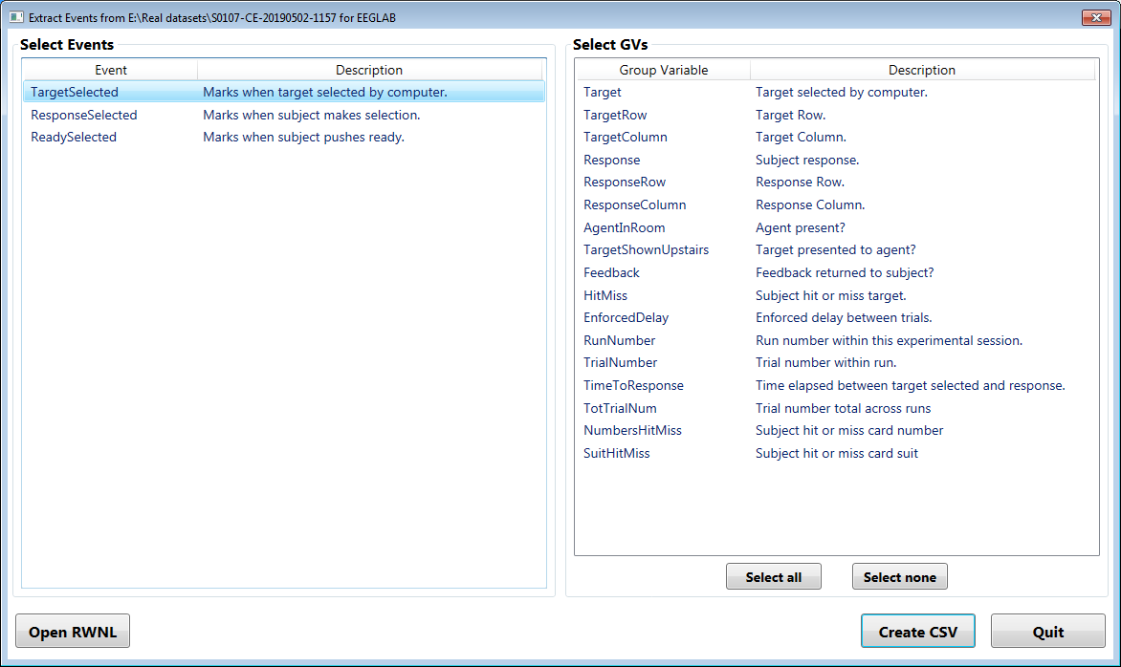

Here we have selected several GVs on the right-hand panel. The values of these selected GVs will be included in the CSV output file.

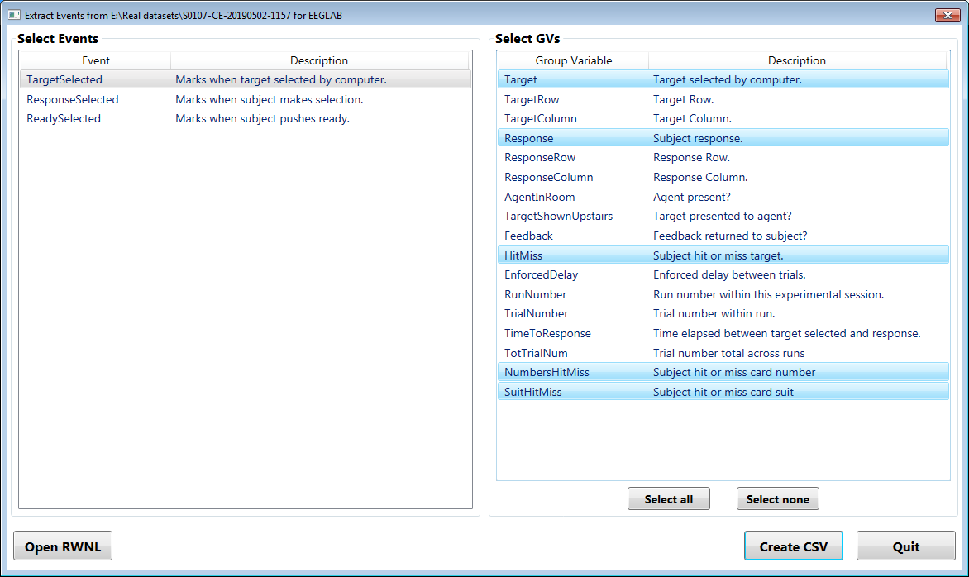

Shortcut buttons are provided to select all or none of the displayed GVs. Finally click on “Create CSV” to generate the required file for import into EEGLAB.

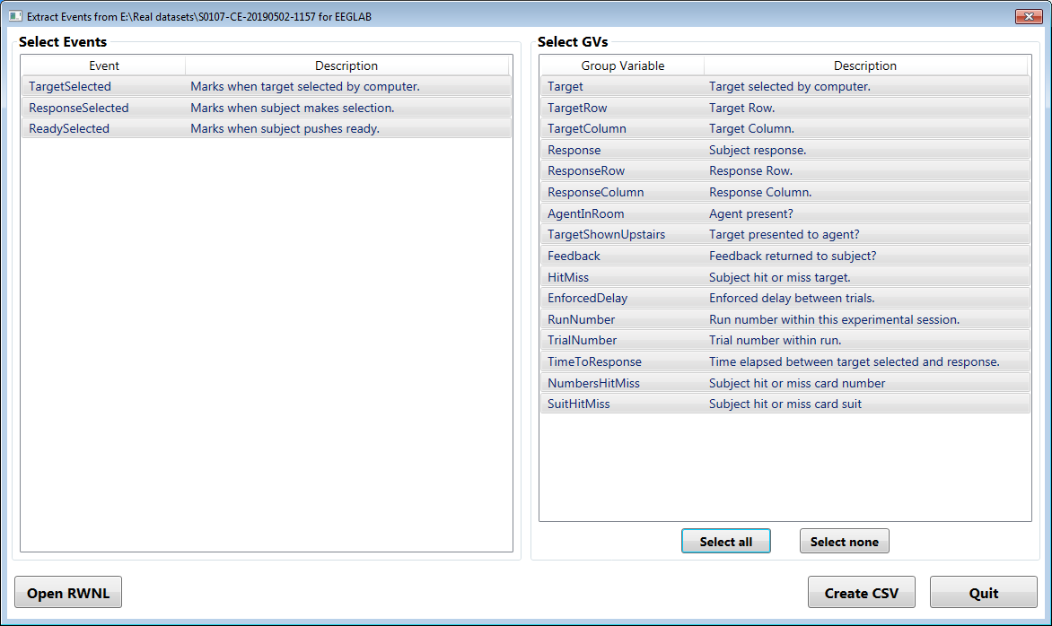

This results in a CSV file in the folder containing the dataset, using the name of the dataset with an extension of “.evt.csv” as shown below. Note that file contains one line for each occurrence of the selected Event types. The first line in the file contains the labels for the “columns”. The first is the index of the Event, followed by the time of the Event in seconds (corrected for any extrinsic Events), and the name of the Event type. The values for all the selected GVs are then listed in order. The Event types and the labels for the GVs are as listed in the HDR file of the dataset with any spaces replaced by “_”. The GV values are derived from the GV dictionaries in the HDR files with spaces again changed to “_”. If no dictionary for a particular GV is present, its numerical value is used.

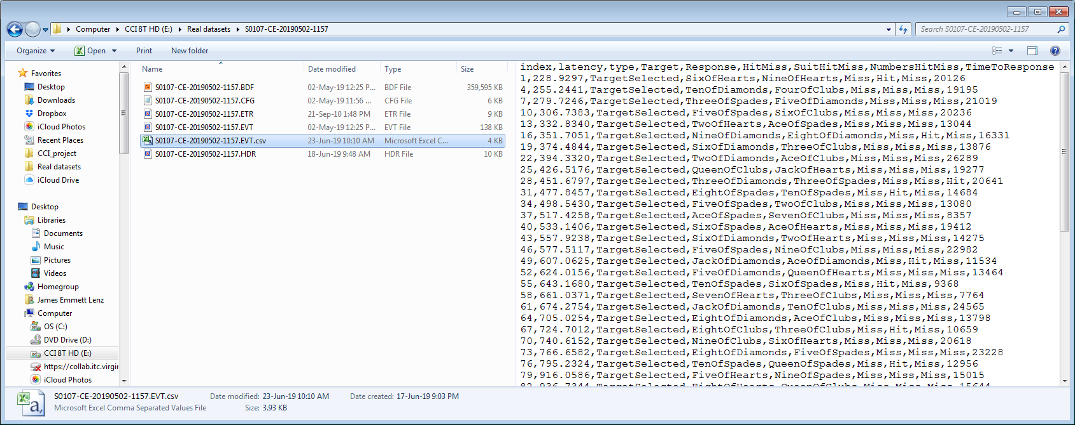

Once the CSV file is completed (less than a second), the display is returned to its initial state and is ready for the selection of another RWNL dataset. Note that because of the automatic naming system, if more than one CSV file is to be created for a given dataset, each should be manually renamed before the next is created.